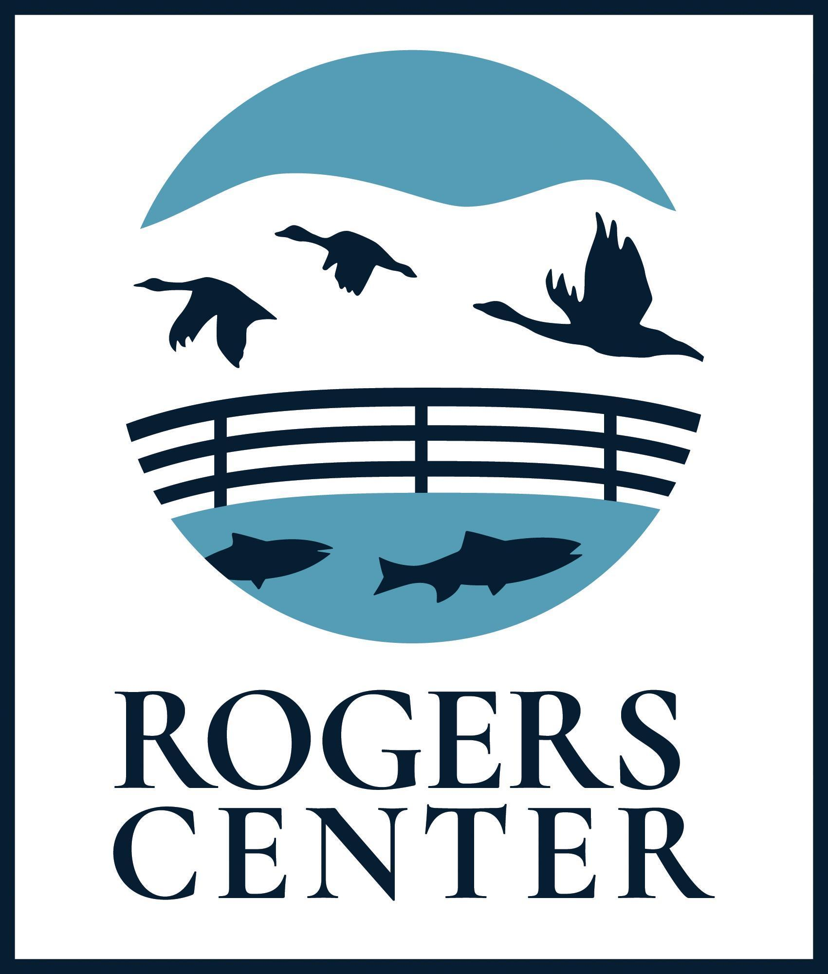
Rogers Environmental Education Center
2721 State Highway 80
Sherburne, NY 13460
(607) 674-4733
friendsofrogers.org
ellen@friendsofrogers.org

ENVIRONMENTAL EDUCATOR INTERNSHIP
POSITION DESCRIPTION

This variable length internship will provide a variety of opportunities for exceptionally qualified candidates to work with the Friends of Rogers (FOR) team to deliver school programs and public programs, special events, and special project assignments. This position is generally available in the Spring and Fall, during peak school field trip season. Applicants with specialized interests, such as media and marketing, content creation, ecosystem restoration, aquaculture, etc. are encouraged to apply. This position is a part-time, non-exempt (hourly) position reporting to the Executive Director and Senior Educator. The hourly base rate is $14.50 per hour.

Key Responsibilities:
- Work closely with the Executive Director, Senior Educator and FOR staff in supporting our mission to provide outstanding educational opportunities that excite, inspire, and motivate people of all ages and abilities to enjoy, understand, appreciate, and protect our natural environment.
- Teach environmental education lessons, lead trips and programs, and assist as needed to fulfill the programmatic needs of school programs.
- Support and assist FOR staff in the development and delivery of school programs, public programs, and special project assignments.
- Develop and implement education, recreation, and work projects.
- Interact with the community through on-site engagement and local outreach.
- Greet and interact with visitors to the Visitor Center.
- Complete an environmental education project.
- Participate in instructor training events and activities.
- Assist with other projects, programs, and duties as needed.
Qualifications and Key Attributes:
- Enrolled in a degree program in natural resources, environmental studies, environmental education, STEM, or elementary-middle-secondary-special education with at least 60 semester hours of college credit. Lived and/or work experience may be a sufficient substitute for college credits, and all applicants are encouraged to apply.
- Demonstrated commitment and dedication to environmental education, passion for the outdoors, and excitement for outdoor recreation.
- Teaching experience or experience working with children.
- Excellent communication skills with an ease and enthusiasm for talking to individuals of all ages.
- Ability to always interact in a positive and professional manner.
- Ability to work independently or as part of a team, indoors and outside under variable weather conditions.
- Flexibility and adaptability to work in a fast-paced environment.
- 18 years of age or older.

Friends of Rogers is an equal opportunity employer. FOR will not discriminate against any applicant for employment on any basis including, but not limited to: race, color, religion, sex, sexual orientation, gender identity, national origin, age, disability, military and/or veteran status, marital status, predisposing genetic characteristics and genetic information, or any other classification protected by federal, state and local laws.

