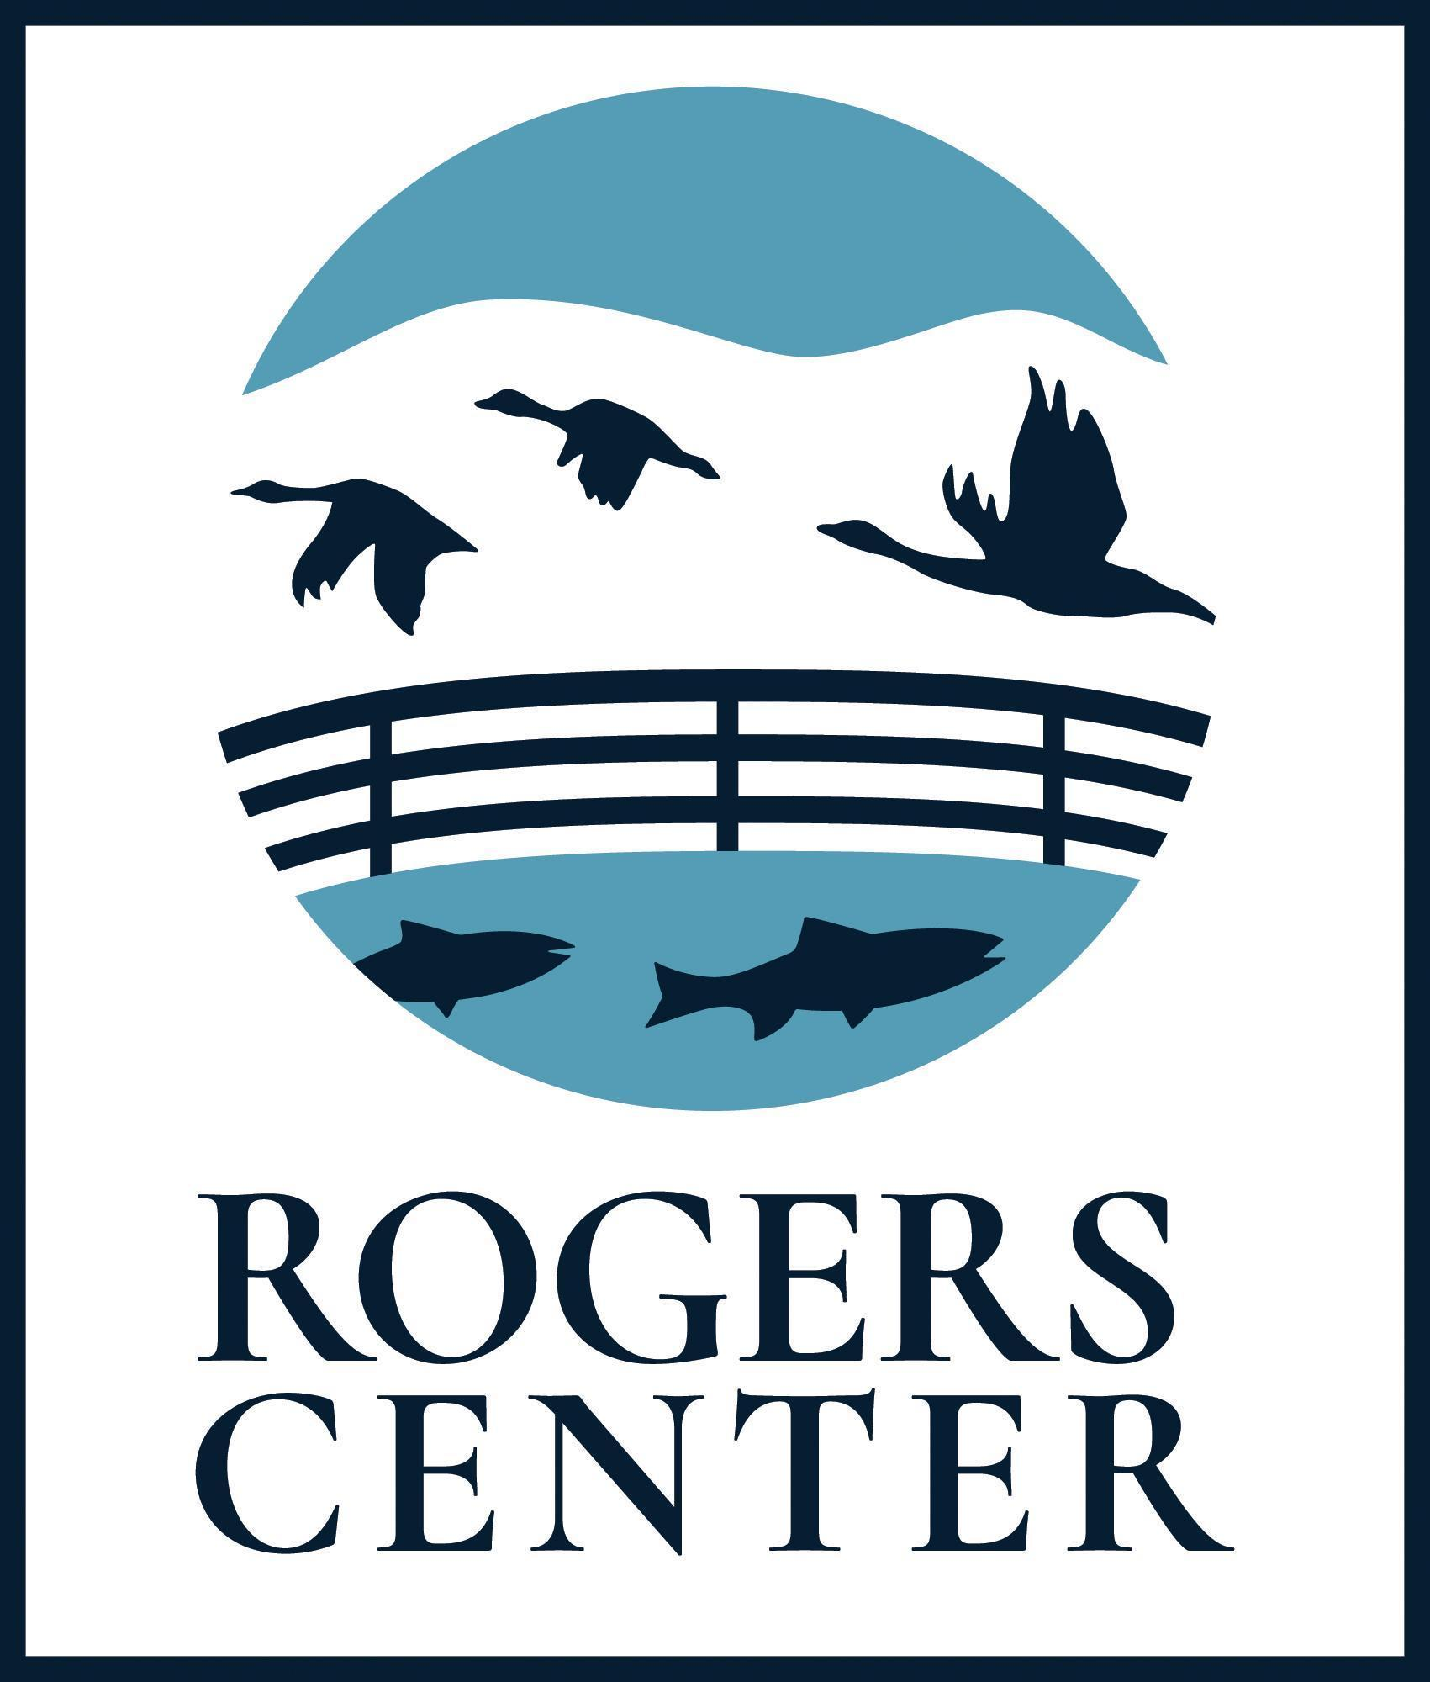
Rogers Environmental Education Center
2721 State Highway 80
Sherburne, NY 13460
(607) 674-4733
friendsofrogers.org
ellen@friendsofrogers.org

SUMMER CAMP EDUCATOR INTERNSHIP
POSITION DESCRIPTION

This eight week internship provides a variety of opportunities for qualified candidates to work with the Friends of Rogers (FOR) team in the Summer Adventure Camp program. Our interns are responsible for building out summer camp program details and schedules, managing rambunctious and curious kids, and inspiring a love and appreciation for the outdoors through fun and exploration. While the majority of responsibilities relate to the delivery of summer camp lessons and activities, we encourage interns to apply who have specialized interests in environmental science and education, and who are eager to learn how they can build upon their passion to develop programs that are fun and engaging. Reporting to the Executive Director and Senior Educator, this is a non-exempt (hourly) position working 37.5 hours per week. The hourly base rate is $14.50 per hour.

Key Responsibilities:
- Work closely with the Executive Director, Senior Educator, and FOR staff in supporting our mission to provide outstanding educational opportunities that excite, inspire, and motivate people of all ages and abilities to enjoy, understand, appreciate, and protect our natural environment.
- Build out summer camp programs and schedules, manage and teach school-aged children, and inspire a love and appreciation for the outdoors through fun and exploration.
- Assist as needed to fulfill the programmatic needs of the camp program.
- Support and assist other counselors in the development and completion of camp activities.
- Interact with the community through on-site engagement and local outreach.
- Greet and interact with visitors to the Visitor Center.
- Participate in instructor training events and activities.
- Assist with other projects, programs, and duties as needed.
Qualifications and Key Attributes:
- Enrolled in a degree program in natural resources, environmental studies, environmental education, STEM, or elementary-middle-secondary-special education with at least 30 semester hours of college credit. Lived and/or work experience may be a sufficient substitute for college credits, and all applicants are encouraged to apply.
- Demonstrated commitment and dedication to environmental education, passion for the outdoors, and excitement for outdoor recreation.
- Teaching experience or experience working with children.
- Excellent communication skills with an ease and enthusiasm for talking to individuals of all ages.
- Ability to always interact in a positive and professional manner.
- Ability to work independently or as part of a team, indoors and outside under variable weather conditions.
- Flexibility and adaptability to work in a fast-paced environment.
- 18 years of age or older.

Friends of Rogers is an equal opportunity employer. FOR will not discriminate against any applicant for employment on any basis including, but not limited to: race, color, religion, sex, sexual orientation, gender identity, national origin, age, disability, military and/or veteran status, marital status, predisposing genetic characteristics and genetic information, or any other classification protected by federal, state and local laws.

